Experiment 4.3
Analysis of Discrete System
Aim:
The Aim of this test case is to analyze a discrete-time system by applying an input signal and examining the output. The analysis will involve determining whether the system is linear, time-invariant, causal, or stable based on the input-output relationship.
Program:
% Analysis of Discrete-Time System
clc;
clear;
close all;
% Input sequence
n = 0:10;
x = [1 2 3 4 5 6 7 8 9 10 11];
% System: y(n) = x(n) + 0.5x(n-1)
b = [1 0.5];
a = [1];
y = filter(b,a,x);
% Display output
disp('Input Sequence x(n):');
disp(x);
disp('Output Sequence y(n):');
disp(y);
% Plotting
figure;
subplot(2,1,1);
stem(n,x,'filled');
grid on;
title('Input Sequence x(n)');
xlabel('n');

ylabel('Amplitude');
subplot(2,1,2);
stem(n,y,'filled');
grid on;
title('Output Sequence y(n)');
xlabel('n');
ylabel('Amplitude');
Output Waveform:
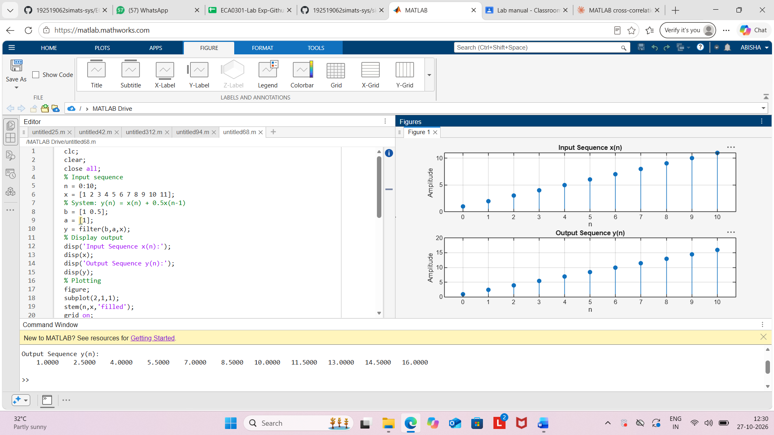
Result:
The discrete-time system y(n)=x(n)+0.5x(n−1) was analyzed using MATLAB. The output
sequence was obtained by combining the present input sample with half of the previous
sample, and the system response was successfully observed through stem plots.

